
Touchstones Project
Netcards

Resilience Netcards with Text

Bamboo HRJ
Black Lives Matter HRJ
Child Laughing HRJ
Coconut HRJ

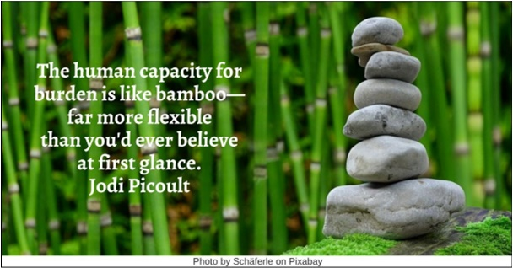



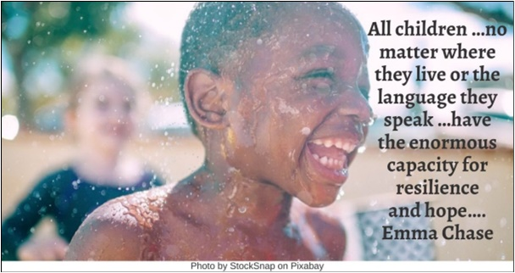

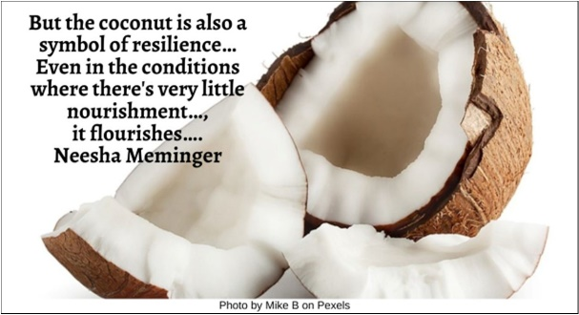

Crazy HRJ
Dandelion HRJ
Failure HRJ
Father and Child HRJ



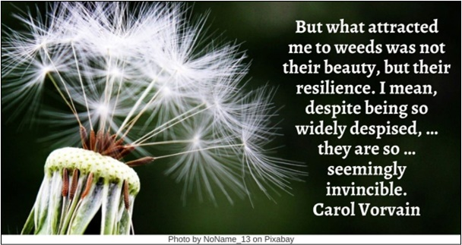

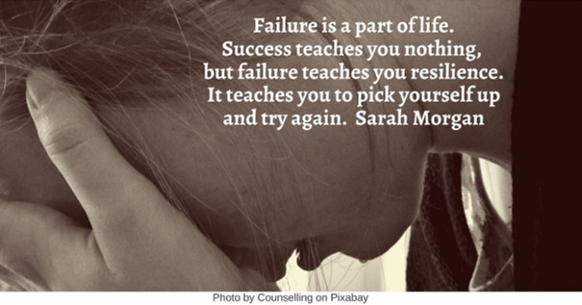

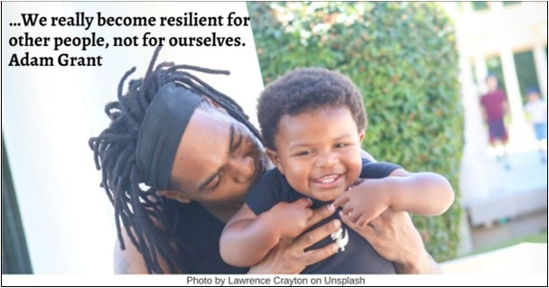

Galveston Hurricane HRJ
Hawk HRJ
Heart HRJ
Helping HRJ

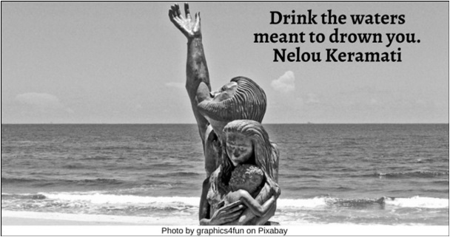

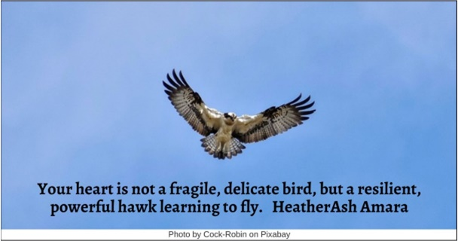

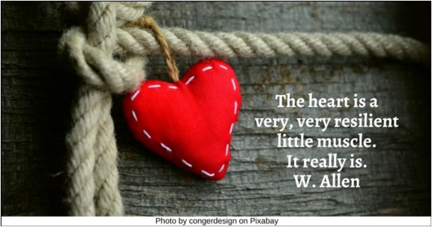

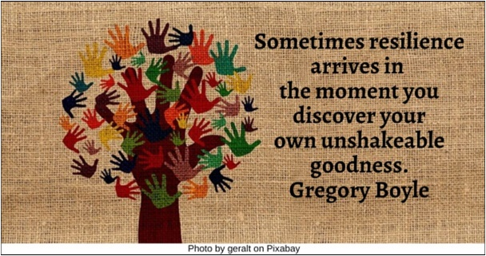

Hug HRJ
Imagination HRJ
Immigrants HRJ
Laughing HRJ

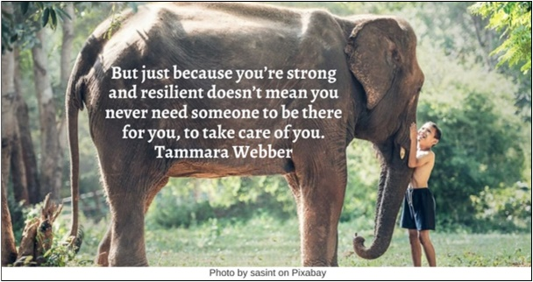

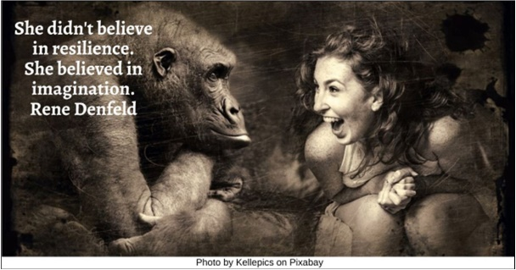

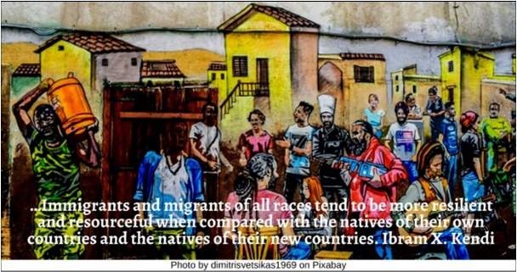

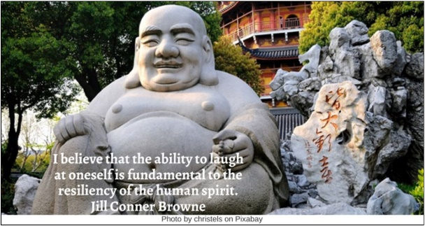

Lotus HRJ
Love HRJ
Mosaic HRJ
Mountain Stream HRJ

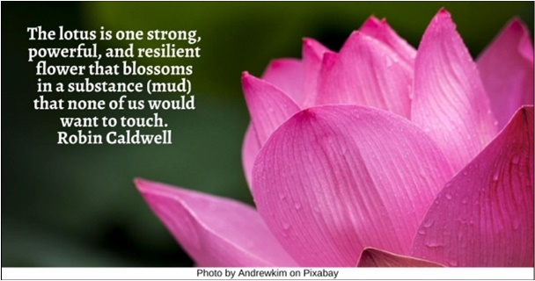





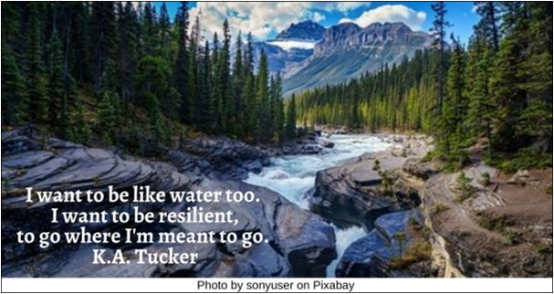

Nature HRJ
No Bullying HRJ
Nothing HRJ
Path HRJ

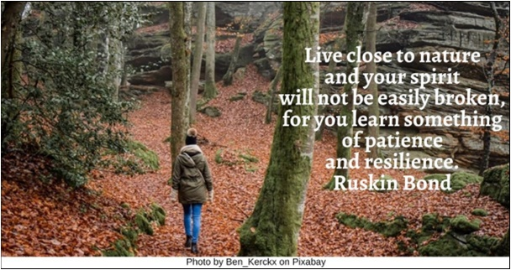

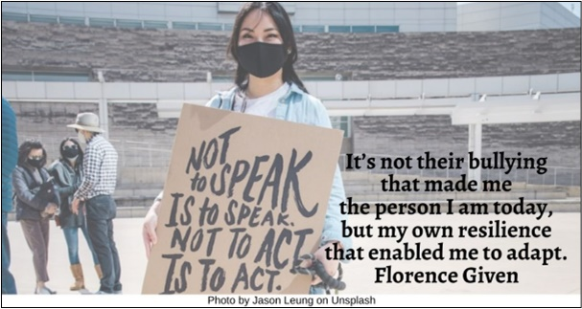

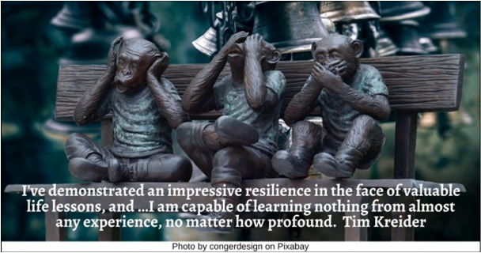

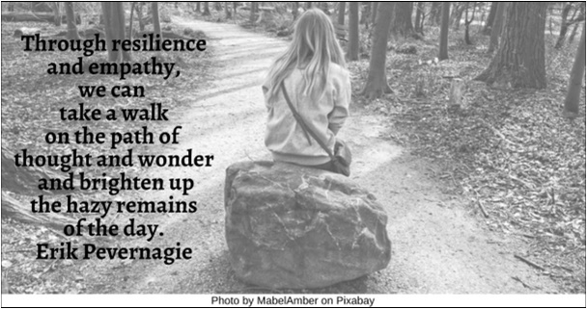

Rainbow Children HRJ
Reading HRJ
Seedling HRJ
Thinker HRJ

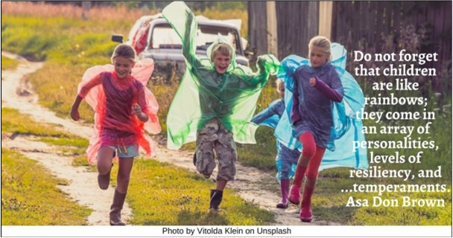



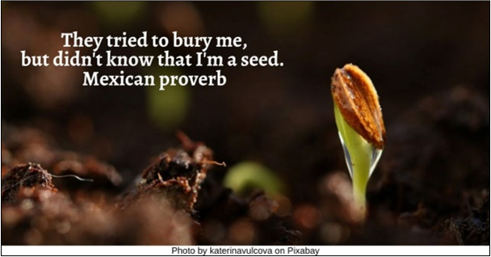

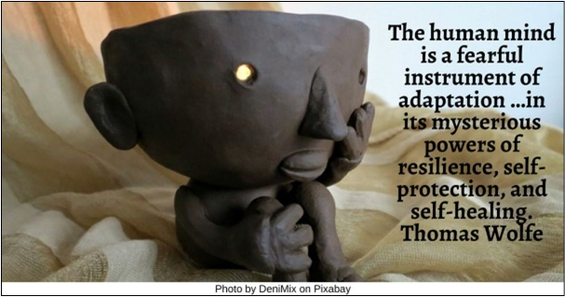

Water HRJ
Wildflower HRJ
Willow Tree HRJ

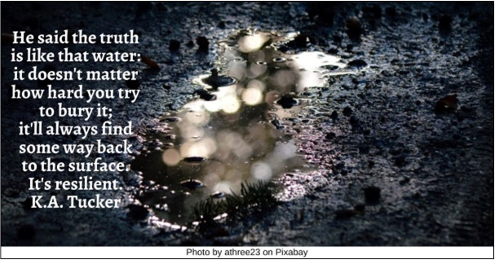

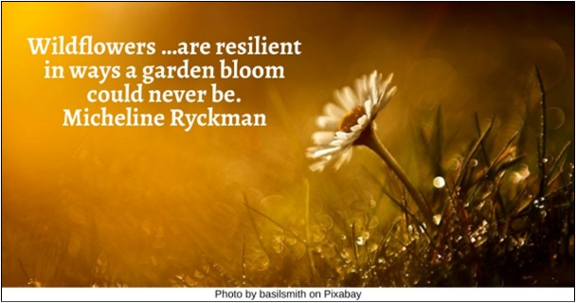

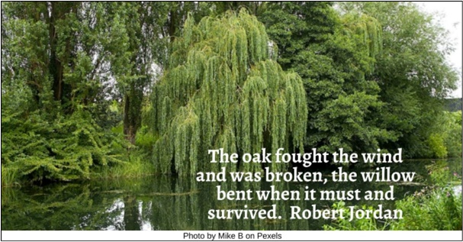

Text of Quotes
Bamboo HRJ
The human capacity for burden is like bamboo—far more flexible than you'd ever believe at first glance. Jodi Picoult

Black Lives Matter HRJ
A formidable array of policy assaults and legal contortions has consistently punished black resilience, black resolve. Carol Anderson

Child Laughing HRJ
All children …no matter where they live or the language they speak …have the enormous capacity for resilience and hope…. Emma Chase

Coconut HRJ
But the coconut is also a symbol of resilience… Even in the conditions where there's very little nourishment…, it flourishes…. Neesha Meminger

Crazy HRJ
When small towns find they cannot harm the strangest of their members, when eccentrics show resilience, they are eventually embraced…. Louise Erdrich

Dandelion HRJ
But what attracted me to weeds was not their beauty, but their resilience. I mean, despite being so widely despised, …they are so …seemingly invincible. Carol Vorvain

Failure HRJ
Failure is a part of life. Success teaches you nothing, but failure teaches you resilience. It teaches you to pick yourself up and try again. Sarah Morgan

Father and Child HRJ
…We really become resilient for other people, not for ourselves. Adam Grant

Galveston Hurricane HRJ
Drink the waters meant to drown you. Nelou Keramati

Hawk HRJ
Your heart is not a fragile, delicate bird, but a resilient, powerful hawk learning to fly. HeatherAsh Amara

Heart HRJ
The heart is a very, very resilient little muscle. It really is. W. Allen

Helping HRJ
Sometimes resilience arrives in the moment you discover your own unshakeable goodness. Gregory Boyle

Hug HRJ
But just because you’re strong and resilient doesn’t mean you never need someone to be there for you, to take care of you. Tammara Webber

Imagination HRJ
(She) didn't believe in resilience. She believed in imagination. Rene Denfeld

Immigrants HRJ
…Immigrants and migrants of all races tend to be more resilient and resourceful when compared with the natives of their own countries and the natives of their new countries. Ibram X. Kendi

Laughing HRJ
I believe that the ability to laugh at oneself is fundamental to the resiliency of the human spirit. Jill Conner Browne

Lotus HRJ
The lotus is one strong, powerful, and resilient flower that blossoms in a substance (mud) that none of us would want to touch. Robin Caldwell
Love HRJ
In the end, love wins. …We know it wins. …It is an amazingly resilient part of us. J.K. Rowling

Mosaic HRJ
If your heart is broken, make art with the pieces. Shane Koyczan

Mountain Stream HRJ
I want to be like water too. I want to be resilient, to go where I'm meant to go. K.A. Tucker

Nature HRJ
Live close to nature and your spirit will not be easily broken, for you learn something of patience and resilience. Ruskin Bond

No Bullying HRJ
It’s not their bullying that made me the person I am today, but my own resilience that enabled me to adapt. Florence Given

Nothing HRJ
I've demonstrated an impressive resilience in the face of valuable life lessons, and …I am capable of learning nothing from almost any experience, no matter how profound. Tim Kreider

Path HRJ
Through resilience and empathy, we can take a walk on the path of thought and wonder and brighten up the hazy remains of the day. Erik Pevernagie

Rainbow Children HRJ
Do not forget that children are like rainbows; they come in an array of personalities, levels of resiliency, and …temperaments. Asa Don Brown

Reading HRJ
You cannot learn resilience by reading a book or listening to a lecture. Yuval Noah Harari

Seedling HRJ
They tried to bury me, but didn't know that I'm a seed. Mexican proverb

Thinker HRJ
The human mind is a fearful instrument of adaptation …in its mysterious powers of resilience, self-protection, and self-healing. Thomas Wolfe

Water HRJ
He said the truth is like that water: it doesn't matter how hard you try to bury it; it'll always find some way back to the surface. It's resilient. K.A. Tucker

Wildflower HRJ
Wildflowers …are resilient in ways a garden bloom could never be. Micheline Ryckman

Willow Tree HRJ
The oak fought the wind and was broken, the willow bent when it must and survived. Robert Jordan

